Current and past bt603 solved past papers:
Mcqs kch past me sy b thy....subjective past me sy aya..bx 2 3 questions different thy..
Flow chart of inocula. 10 marks:
Bull et al 5 pattern of form forming:
Hall et al. (1973) have recognized five patterns of foaming in
fermentations:
1. Foaming remains at a constant level throughout the
fermentation. Initially it is due to the medium and later due
to microbial activity.
2. A steady fall in foaming during the early part of the
fermentation, after which it remains constant. Initially it is
due to the medium but there are no later effects caused by
the micro-organism.
3. The foaming falls slightly in the early stages of the
fermentation then rises. There are very slight effects caused
by the medium but the major effects are due to microbial
activity.
4. The fermentation has a low initial foaming capacity which
rises. These effects are due solely to microbial activity.

...flow chart waly 2 question thy..
.physical characteristics in identification of microorganisms.
. Trace elements... 2
names of sample collection organization.
National Collection of
Type cultures (NCTC)
PHLS Central Public Health Laboratory, 61
Colindale Avenue, London NW9 5HT, UK
National Collections of
Industrial and Marine
Bacteria Ltd. (NCIB,
NCMB)
23 St Machar Drive, Aberdeen AB2 1RY, UK
National Collection of
Yeast Cultures (NCYC)
AFRC Institute of Food Research, Norwich
Laboratory, Colney Lane, Norwich NR4
7UA, UK
American Type Culture
Collection (ATCC)
12301 Parklawn Drive, Rockville, MD
20852, USA
.methods of foreign DNA in organisms..
Write equation of oxidation of glucose

Genetic technique for characterization of microbe
Genotypic characteristics
• Nucleic acid probes
• DNA amplification
• Ribotyping
Genotypic Characterization (Nucleic acid probes)
•Used to locate unique sequences
Single-stranded DNA (or RNA)
•Generally labeled (radioactive or fluorescent)
Complementary to the sequence of interest
Observe and identify intact microorganisms
•Fluorescence in situ hybridization (FISH)
Observe and identify samples
•DNA amplification by PCR
Specific primers are used
Phenotypic technique for microbe characterization
Phenotypic characteristics
• Microscopic morphology
• Metabolic differences (Biochemical Testing)
• Serology
• Fatty acid analysis
Aik graph wala kuch tangent wala tha i think oxygen balance technique waly topic sy tha k graph mein tangent ka show kr rha hai
Aik dynamic gass out method wala graph aya tha
Dynamic Method of Gassing-out
Respiratory activity of a growing culture in the
fermenter is utilized to lower the oxygen level prior to
aeration. Therefore, the estimation has the advantage of
being carried out during a fermentation which should
give a more realistic assessment of the fermenter's
efficiency.

Methods for foreign Dna in organism
Methods involving DNA foreign to the organism (i.e.
recombination)
2. Transduction
3. Conjugation
4. Transformation
6. Protoplast fusion
7. Genetic engineering
8. Metabolic engineering
9. Site-directed mutagenesis

Streak plate method 10 marks
The isolation method most commonly used to get pure
cultures is the streak plate method (Figure on next
slide). A sterile inoculating loop is dipped into a mixed
culture that contains more than one type of microbe and
is streaked in a pattern over the surface of the nutrient
medium. As the pattern is traced, bacteria are rubbed
off the loop onto the medium. The last cells to be
rubbed off the loop are far enough apart to grow into
isolated colonies. These colonies can be picked up with
an inoculating loop and transferred to a test tube of
nutrient medium to form a pure culture containing only
one type of bacterium
Streak plate
method for pureculturing of
required
microorganism is
done for nonfilamentous
unicellular
microorganisms
only.
The most desirable
isolation medium
would be one which
selects for the
desired types and
also allows
maximum genetic
expression. Cultures
grown on such
media could then be
used directly in a
screen
However,
it is more common
that, once isolated,
the organisms
are grown on a
range of media
designed to
enhance
productivity.
Flow chart for using microorganism in industry General and specific inhibtor

Trace elements
The role of trace elements in medium formulation can be significant. Cultured cells normally require Fe, Zn, Cu, Se, Mn, Mo and V. These are often present as impurities in other media components. Cleveland et al. (1983) found that if the number of trace elements were increased, insulin, transferrin, albumin and liposomes were not needed in a serum-free hybridoma medium. They included AI, Ag, Ba, Br, Cd, Co, Cr, F, Ge, J, Rb, Zr, Si, Ni and Sn as well as those previously mentioned.

BT 603 – current solved past paper
- Fermentation actually comes from Latin word “fervere” which means “to boil”
- Fermentation can be classified into different types on the basis of followings:
- Oxygen (O₂) Need
- Production Scale
- State/Mixing
- All of above
- Pilot and industrial scale fermentations are normally carried out in stirred, aerated vessels
- Examples of Bioweapons
- Smallpox
- Anthrax
- Botulinum toxin
- All of above
- Constitutive enzyme: An enzyme that is synthesized continually regardless of growth conditions.
- In 1900-1940 Citric acid is produced
- On the basis of state or mixing fermentation can be Shake-Flask Fermentation
- Downstream Processing includes the recovery of the products in a pure state and the effluent treatment.
- A medium with a high viscosity will also need a higher power input for effective stirring
- Reducing media contain ingredients, such as sodium thioglycolate, that chemically combine with dissolved oxygen and deplete the oxygen in the culture medium.
- Cellular yield coefficient of n-alkanes 1.03
- Carbohydrate composition of barley malt (expressed as % dry weight of total) of Reducing sugars 3-4
- Trace element Mn influencing primary and secondary metabolites production of Bacitracin
- In processes used for the production of glutamic acid, limited concentrations of biotin must be present in the medium
- Phenylacetic acid is still the most widely used precursor in penicillin production.
- potential chlorination inhibitors, e.g. bromide,
- heterologous proteins may show some degree of toxicity to the host and have a major influence on the stability of heterologous protein expression.
- The individual components of the medium can influence the viscosity of the final medium and its subsequent behaviour with respect to aeration and agitation.
- Trace elements were increased; insulin, transferrin, albumin and liposomes were not needed included Co
- The foaming can cause removal of cells from the medium which will lead to autolysis
- The foam is unavoidable and antifoam should be used.
- many antifoams are of low solubility
- independent variable (nutrient, antifoam, pH, temperature, etc.)
- When more than five independent variables are to be investigated, the Plackett-Burman design may be used
- The oxygen demand of an industrial fermentation process is normally satisfied by aerating and agitating the fermentation broth.
- The solubility of oxygen in pure water is 8 mg/L at 4ºC.
- Production of 100 grams of biomass from hydrocarbon requires approximately three times the amount of oxygen to produce the same amount of biomass from carbohydrate.
- maximum biomass production may be achieved by satisfying the organism's maximum specific oxygen demand by maintaining the dissolved oxygen concentration greater than the critical level
- Sulphite Oxidation technique does not require the measurement of dissolved oxygen concentrations
- Two methods have been employed to achieve this lowering of the dissolved oxygen concentration - the static method and the dynamic method.
- (NCTC) abbreviation of? National Collection of Type cultures
- The isolation method most commonly used to get pure cultures is the streak plate method
- lyophilization (freeze-drying)
- the process of
- strain improvement involves the continual genetic modification of the culture,
- Protoplast fusion has been demonstrated as an efficient way to induce hetero-karyon formation and recombination with high frequency.
- Auxotrophy is the inability of an organism to synthesize a particular organic compound required for its growth
- The quantity of inoculum normally used is between 3 and 10% of the medium volume
Q:- what is Site-Directed Mutagenesis? (2)
- Site-specific mutation commonly involve using mutagenic oligonucleotides in a primer extension reaction with DNA polymerase.
- This method allows for point mutation, or deletion or insertion of small stretches of DNA to be introduced at specific sites.
Q: Two examples of Methylotrophic yeasts?
Methylotrophic yeasts such as Hansenula polymorpha and Pichia pastoris
Q: Draw a graph showing The effect of dissolved oxygen concentration on the Q_{O2} of a microorganism?
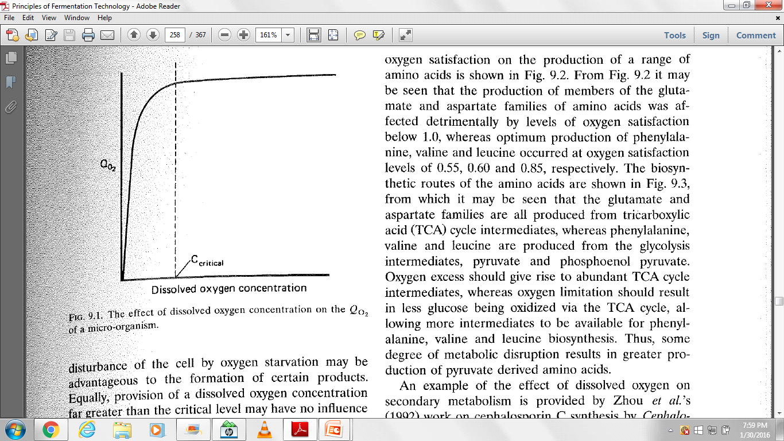
Q: Define Henry’s Law?
Henry’s Law describes the solubility of O₂ in nutrient solution in relation to the O₂ partial pressure in the gas phase

C* is the oxygen saturation concentration of the nutrient solution,
P_{o} is the partial pressure of the gas in the gas phase
H is Henry's constant, which is specific for the gas and the liquid phase.
Q: Bull et al. (1979) cited criteria in the choice of process organism? (10)
Q: What is Replica Plating Method? (5)
Mutants can be detected by selecting or testing for an altered phenotype. Positive selection involves the selection of mutant cells and rejection of non-mutated cells. To identify mutants that have gained some physical trait, Replica plating is used for negative selection. Negative selection identifies mutants that have lost some physical trait - for example, auxotrophs that have nutritional requirements not possessed by the parent (nonmutated) cell.
Q: Draw a flow chart for INDUSTRIAL STRATEGY FOR USAGE OF MICROORGANISMS? (5)

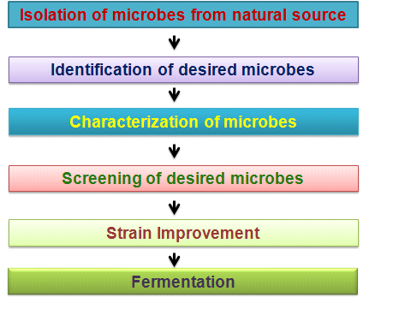
Q: Phenotypic characteristics to characterize and identify microorganisms (3)?
- Microscopic morphology
- Metabolic differences (Biochemical Testing)
- Serology
- Fatty acid analysis

Q: Name Trace elements use in fermentation media, any five (3)
The role of trace elements in medium formulation can be significant. Fe, Zn, Cu, Se, Mn, Mo and V. AI, Ag, Ba, Br, Cd, Co, Cr, F, Ge, J, Rb, Zr, Si, Ni and Sn
a
2. Types,only name of water need fermentation
n the basis of
water/ moisture
requirement ,
process can be:
 Solid State
 Submerged/
Liquid
 Surface Culture/
Jelly
3. Formula for calculating corbon source.Midterm solved ppr
4. Ph long question

5. Difrence in situ ex situ
6. Name oxygen need base fermentation.
7. streak plate methode 10 marks
The isolation method most commonly used to get pure
cultures is the streak plate method (Figure on next
slide). A sterile inoculating loop is dipped into a mixed
culture that contains more than one type of microbe and
is streaked in a pattern over the surface of the nutrient
medium. As the pattern is traced, bacteria are rubbed
off the loop onto the medium. The last cells to be
rubbed off the loop are far enough apart to grow into
isolated colonies. These colonies can be picked up with
an inoculating loop and transferred to a test tube of
nutrient medium to form a pure culture containing only
one type of bacterium.
Streak plate
method for pureculturing of
required
microorganism is
done for nonfilamentous
unicellular
microorganisms
only.

8. air bubble
9. write and explain equation forign dna in organism
10. Ams test..? 2Ames Test
The Ames test is a relatively inexpensive and rapid
test for identifying possible chemical carcinogens.
The test assumes that a mutant cell can revert to a
normal cell in the presence of a mutagen and that
many mutagens are carcinogens.
Histidine auxotrophs (require histidine in the media)
of Salmonella are exposed to an enzymatically treated
potential carcinogen, and reversions to the
nonmutant state are selected.
11. Lyophilization..? 3During lyophilization (freeze-drying), a suspension of
microbes is quickly frozen at temperatures ranging from
-54°C to -72°C, and the water is removed by a high
vacuum (sublimation). While under vacuum, the
container is sealed by melting the glass with a hightemperature torch. The remaining powder like residue
that contains the surviving microbes can be stored for
years. The organisms can be revived at any time by
hydration with a suitable liquid nutrient medium.
12. Equation of oxygen transfer from air bubble to liquid medium..? 5

13. Ek question bull 1992 contributions that(3)
Bull (1992) summarized the major contributions as
follows:
1. The provision of test organisms that have increased
sensitivities, or resistances, to known agents. For
example, the use of super-sensitive strains for the
detection of β-lactam antibiotics.
2. The cloning of genes coding for enzymes or receptors
that may be used in inhibitor or binding screens
makes such materials more accessible and available in
much larger amounts.
3. The development of reporter gene assays. A reporter
gene is one which codes for an easily assayable
product so that it can be used to detect the activation
of a control sequence to which it is fused.
14. What is malt.? 2mrks
Barley grains may be partially germinated and heat treated
to give the material known as malt, which contains a variety
of sugars besides starch. Malt is the main substrate for
brewing beer. Malt extracts may also be prepared from
malted grain.
15. Exsitu and insitu sterilization.? 2mrks
16. Name Types of fermentation on the basis of oxygen need..? 3
The O₂ supply must
be according to need
of the process of
fermentation:
 Aerobic
Fermentation
 Semi-anaerobic
Fermentation
 Anaerobic
Fermentation
 Aerobic
Fermentation
➢Aerobic
fermentation is
carried out in the
presence of oxygen.
➢Organisms use
oxygen for the
conversion of
complex organic
compounds.
 Semi-anaerobic
Fermentation
Process in which
organism makes ATP
by aerobic
respiration , but
capable of switching
to anaerobic
respiration if oxygen
is absent.
 Anaerobic
Fermentation
Anaerobic
fermentation is
carried out in the
strict absence of
oxygen; means
presence of oxygen
may be toxic.
17. Limitations of starch..? 3
18. Types of fermenation on basis of water content/moisture and define each type..? 5
19. Explain 5 ways to control pH in fermentation medium..? 5
20. Phenotypic technique?
21. Genotypic technique?
22. Describe henry law?
23. What is bull criteria?
24. Name of specific inhibitors?
25. Why medium is on inhibitors, give two reason esa he kch tha
26. Name of specific inhibitors
27. Method of screening antibiotics?
28. Why antifoam is excess in media give three methods?
Difrence b/w differential and reducing media Difrence b/w differential and reducing media

